Seventeenth-Century Libraries: Problems & Perspectives

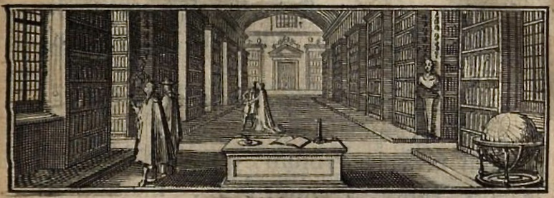
Centre for Editing Lives & Letters (CELL)
University College London

June 6th-8th 2019
Venue: University College London, IAS Common Ground

This symposium brings together a group of UK-based academics and librarians, as well as key Continental scholars, in an attempt to consolidate current research, for the first time, on seventeenth-century libraries and book collecting. Much research has been done, but it remains scattered across disciplinary divides. Until separate findings have been amalgamated, we will not be able to establish the patterns of book acquisition and library formation for this important period.
Seventeenth-Century Libraries: Problems & Perspectives will address questions of topography and typology, networks of library activity, administration, visual identity, dispersal, owners and content, and definitions of public and private. The symposium will also confront current topics of cultural and intellectual history – especially heritage and antiquarianism, the circulation and management of knowledge, and the rise of consumerism and the culture of collecting, as presented in such books as Arthur MacGregor’s Curiosity and Enlightenment (2007), Ann Blair’s Too Much to Know (2010), and Linda Levy Peck’s Consuming Splendor (2005).

Full registration fee (includes tea/coffee on all days, and lunch on Friday): £50
Full day (Friday) only (incluces tea/coffee and lunch): £35
One half-day (Thursday or Saturday) (includes tea/coffee): £15
Please register via UCL online store

For further information, please contact Dr Robyn Adams (robyn.adams@ucl.ac.uk) or Dr Jacqueline Glomski (j.glomski@ucl.ac.uk)
PROVISIONAL PROGRAMME
Thursday, 6 June (1.45 – 5.30)
Classification, Typologies, Arrangement
- Richard Foster (Winchester College), ‘Problems of Classification in Seventeenth-Century English Libraries’
- Shanti Graheli (University of Glasgow), ‘Parisian Libraries at the Turn of the Seventeenth Century’
- Adrian Green (Durham University), ‘Bishop Cosin's Library in Architectural Context’
Keynote
Jill Bepler (Wolfenbüttel), ‘Dynastic Women and Book Collecting in Seventeenth-Century Germany: Fragmented Evidence’
Friday, 7 June (10.00 – 5.30)
Italian, French, and Spanish Books
- Dorit Raines (Università Ca' Foscari, Venezia), ‘The Architecture of Knowledge in Seventeenth-Century Italian Libraries’
- Raphaële Mouren (The Warburg Institute), ‘What about Seventeenth-Century Books in Bibliophile Collections?’
- Alexander Samson (CELL, University College London), ‘Robert Ashley's Spanish Books’
Ministers and their Libraries
- Forrest Strickland (University of St Andrews), ‘Dutch Ministers and the Ideal Library in the Seventeenth Century’
- Barry Taylor (The British Library), ‘The Spanish and Italian Books of Dr William Bates in Dr Williams’s Library, London’
- Alan Argent and Jane Giscombe (Dr Williams's Library) ‘The Books of Cesar Calandrini in Dr Williams's Library, London’
Artists, Women, and Libraries
- Marta Cacho (CRASSH, University of Cambridge), ‘Reading Out Loud, Painting Out Loud: Reading, Conviviality and the Creative Act in Early Modern Studios’
- Jason McElligott (Marsh’s Library, Dublin), ‘Evidence for Female Book Ownership in Seventeenth-Century Libraries’
- Dominique Varry (École nationale supérieure des sciences de l'information et des bibliothèques, Lyon), ‘Tracking a Burgundian Scattered Library’
Special Session
Andrew Pettegree and Arthur der Weduwen (University of St Andrews), ‘Chasing Alexandria: The Public and Private in the Seventeenth-Century Dutch Library’
Saturday, 8 June (10.00 – 1.45)
Collections in London
- Renae Satterley (Middle Temple Library), ‘Robert Ashley: Early Modern Lawyer, Translator, and Bibliophile’
- Ed Potten (Durham University) and Katie Birkwood (Royal College of Physicians), ‘Dispersal and Development: The Building Blocks of the Dorchester Library’
- Elizabeth Wells (Westminster School), ‘“All my best Bookes”: The Libraries of Dr Richard Busby and Dr John Pell’
English Book Owners
- Dunstan Roberts (Corpus Christi College, Cambridge), ‘The Books of Lord Herbert of Cherbury’
- Francesca Galligan (Bodleian Library, University of Oxford), ‘The “Travelling Library” of Charles I’
- David Pearson (University College London), ‘A Directory of Seventeenth-Century English Book Owners’

